Learning Outcome | At the end of this unit, participants will  - Know the basic full chip layout components.  - Know the basic full chip development cycle.  - Understand basic full chip layout considerations.

Introduction | Full chip layout is an integration of all layout blocks/subblocks into a HUGE hierarchical blocks or Full Chip. It is just like any other layout block EXCEPT more complex in terms of  - More # of Subcells/sub-blocks (can be both custom/APR)  - More complex routings/# nets connecting each other sub-blocks.  - More considerations in terms of layout or design for manufacturing. E.g dummifications.  - More quality checks needed.  - More complex project management skill needed to balance between PAS (Performance, Area, Schedule).  - More resources and compute power needed as physically is bigger.

Full Chip in development cycle | 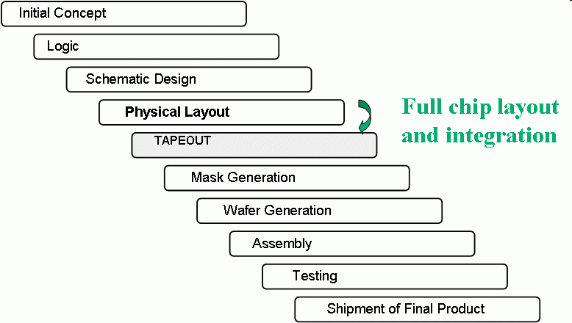  - Fullchip layout work started even before project approved.  - For feasibilities study and evaluations.  - Fullchip actual layout work started in parallel with design.  - Constantly update with latest design info and calibrate/change the floorplans or other global requirements(e.g powers, clocks, timing etc…)  - Fullchip layout activities PEAK at mid to end of design project cycle with intermediate critical tapeout milestones.  - Design/layout work converging to their requirements. (stabilising the FC floorplaning, power, clock etc..)  - Test out all the fullchip layout/tapeout flows. (e.g FC integration, FC verifications, fracturing, DFM requirements etc…)

Full Chip Component  Full Chip Floorplan | - Inputs/Outputs  - IOs, IO buffers, pads, periphery etc.  - Stands for Input/Outputs.  - Main communications gateways which transfer datas between outside world and internal functional units.  - Consists of transistors, ESD structures, diodes, resistors and other protection devices.  - Fully custom, hand-drawn layout.  - Examples : USB, PCI, IDE buffers.  - EmBedded Blocks  - EBBs, datapaths, analog special circuits  - Standalone functional circuits or units which is critical to timings(shortest distance possible), minimum area usage.  - Normally custom hand-drawn layout.  - Examples : RAM, ROM, PLLs,  - Cell Based Design  - CBDs, core, APR, Sea of cells etc.  - Consists of EBBs and sea of standard cells with certain functions and placed quite randomly across an area of the chip.  - Automatically Place and Route.  - Examples : FARM execution units etc…  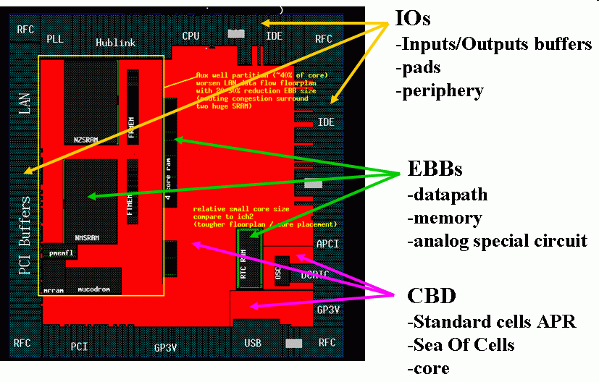

Full Chip Integration | - Full chip Assembly is an ongoing parallel task. It is performed not just once, when all sub-block layout are completed, but at frequent intervals.  - Any block area changes, or block pin changes which affect any growth in area, can be identified and accomodateed as early as possible.  - Pilot and test out all the full chip flows upfront to avoid full chip in critical path.  - Full chip layout are integrated hierarchically.  - Transitors, standard cells, ebbs, units, clusters, fullchip  - Full chip floorplanning is a top down process and bottom up fine tuning.  - Setting the size, shape, and placements of the blocks  - Planning the power, clock and signal routing  - Repeating the process for each lower level of hierarchy  - The floor plan is continually refined by descending into the hierarchy, which provides more details. This work produces area and interface specifics that may require changes and refinements to the upper levels of hierarchy.  This process continues until the EBB floor plan is complete – when the floor plan reflects exact sizes and placements for all the blocks in the EBB, and routing that fully connects all these blocks.

From Single transistor to FC  FC consideration | 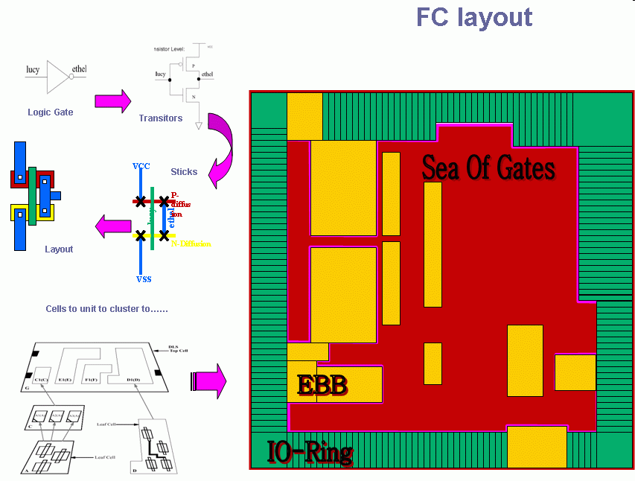  - Optimized die size  - Setting the size, shape, and placements of the blocks  - Pad and Core limited (balanced)  - Database Hierarchies  - Power plan and bussing  - Planning the power, clock and signal routing  - ESD scheme  - CTGEN (Clock Tree Generation)  - Data Flow, PV, Critical timing  - Parasitic extraction

Full Chip Quality Check | - DFM (Design For Manufacturability)  - Density in the chip  - DFT (Design For Testability)  - Fib cells  - Probe cells -- a Mechanical access to the signal (By BIG /marked M1 only with proper “keep-out” and navigation aids.)  - Bonus cells

