Learning Outcome | At the end of this unit, participants will  - Exposed to IC fabrication process

Introduction | Fabrication process today has enabled nanometer technology where a transistor length can be scaled to even 65nm. It was like 0.18u (180nm) in year 2000. There are few common process involved to fabricate the IC and it is closed related to Mask Designer.

Basic Chemical Fabrication Process | - Diffusion  - Doping process attempts to control the types of impurities, impurity distribution profile, and junction depth in the selective region of the semiconductor. The diffusion process is a straightforward method to achieve this goal.  - During diffusion process dopant atoms are inserted into the silicon crystal lattice.  - Acceptors form the p-type silicon by accepting some electrons already present in the silicon hence creating positive charges, called holes.  - Donors supply more electrons thus creating the n-type silicon.  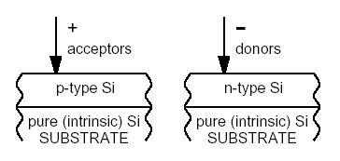  - Oxidation  - Heating the silicon surface in the presence of oxygen (O2) creates a layer of Silicon Dioxide SiO2 (oxide for short) which is a very good insulator.  - Thermal oxidation is used, common in two types, wet oxidation and dry oxidation.  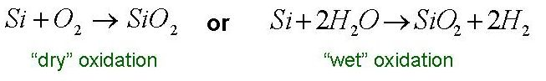  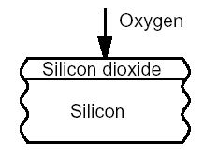

- Deposition
  - Deposition is used to create a layer of a conducting material usually on the top of the silicon dioxide layer. Two conducting materials are used:
    - metal, usually aluminium, Al, and
    - polysilicon, which is a polycrystalline silicon modified with some metal impurities to obtain a relatively good conductance.
  - Two common deposition method:
    - Chemical Vapor Deposition (CVD)
    - Physical Vapor Deposition.

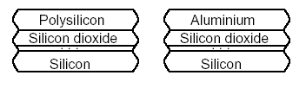

CVD | - Chemical vapor deposition places a film on the substrate by a chemical reaction or decomposition of a gas mixture at the wafer surface. Chemical vapor deposition can be performed independently or integrally by using heat energy, glow-discharge, and violet radiation. Chemical vapor deposition is a fundamentally significant thin film deposition technique in semiconductor technology since many thin film materials such as dielectric and conductor films can be deposited by CVD.  - Poly-Silicon (Polycrystalline Silicon) can be deposited through CVD.  - Wafer is heated to ~600˚C  - Silicon-containing gas (SiH4) is injected into the furnace.  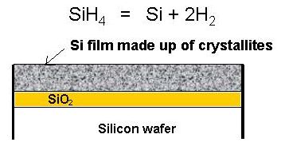  - Photolithography  - Lithography technology is adopted to transfer specific IC patterns onto a wafer. Each layer of an integrated circuit (IC) structure is individually defined on a mask (reticle) before the mask patterns are optically transferred to a photoresist-coated wafer by an exposure system.  - The photoresist layer will contain a pattern similar to the mask after the exposed photoresist is developed when an incident beam from the exposure system passes through the mask and reacts with chemical component of the photoresist.  - The dimension of the whole pattern on the photoresist can be shrunk to a certain ratio that depends on the utilized exposure system. One can generally evaluate the difficulty of an IC process by the number of required lithography steps or masks.  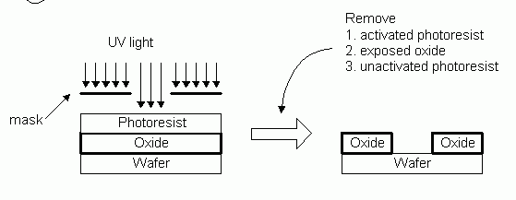
- Etching
  - Etching is employed to form the desired circuit structure that are formed on a wafer by photolithography processes. Materials not covered by the mask are removed during the etching treatment by means of chemical etching, physical sputtering, or combination of the two. Etching techniques are generally categorized into two groups: dry etching and wet etching.
  - Two common etching method:
    - Wet etching
    - Dry etching
CMOS Process Walkthrough | 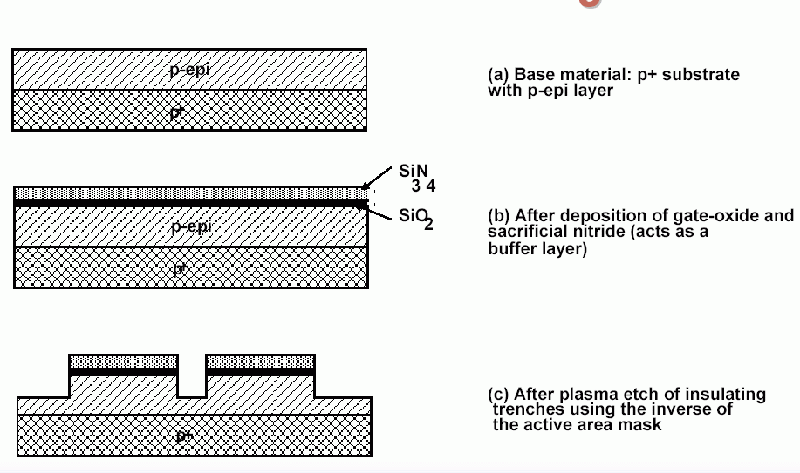  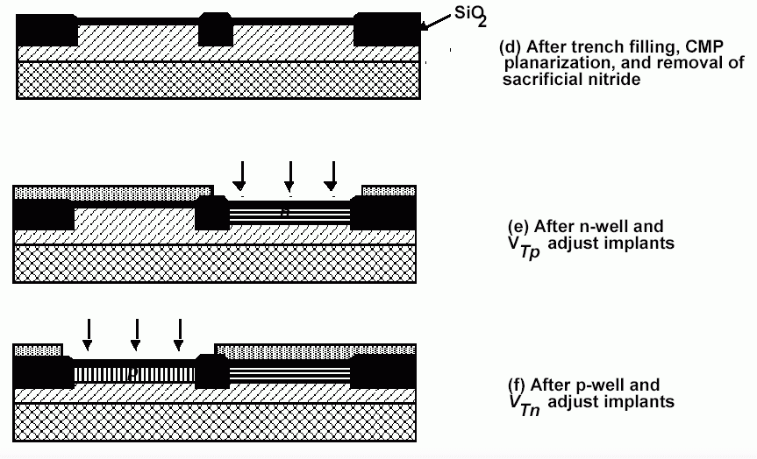  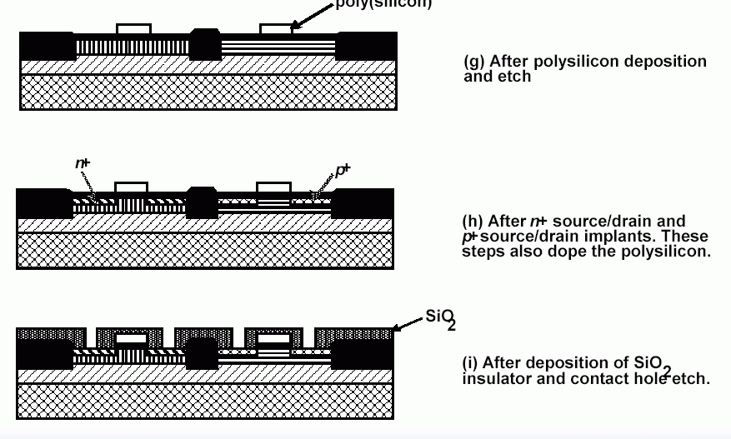  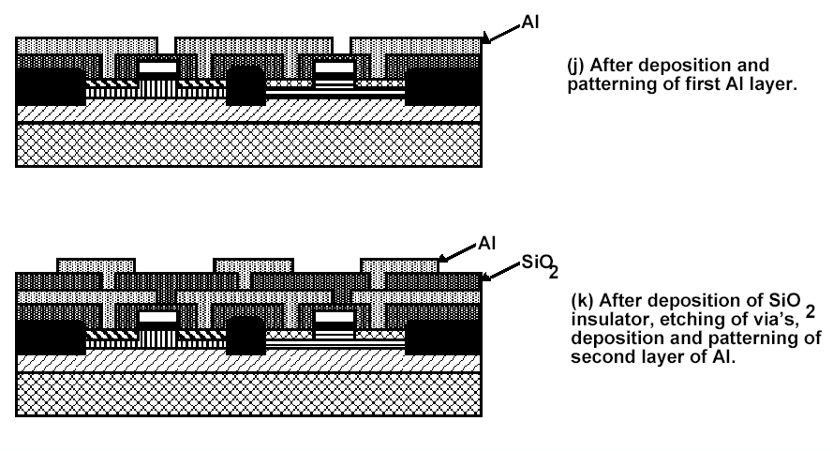

Packaging | 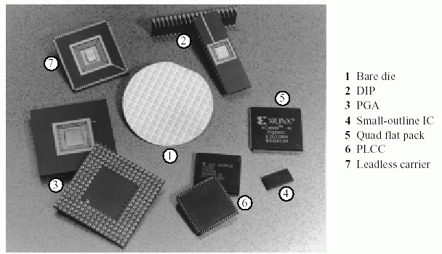

Reference | - http://www.ndl.gov.tw/english/icfab/m3-8.htm  - Prof. Kaustav Banerjee’ s note.

