Learning Outcome | At the end of this unit, participants will  - Understand basic digital logic  - Understand Boolean algebra

Basic Digital Gates  Inverter  AND  OR  NAND  NOR | - In digital world, there will be only two value in general, either high or low (1 or 0).  - Basic gates including NOT (inverter), AND, OR, NAND, NOR, XOR.  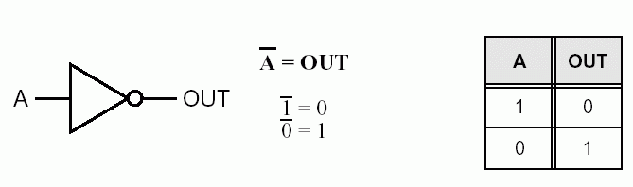  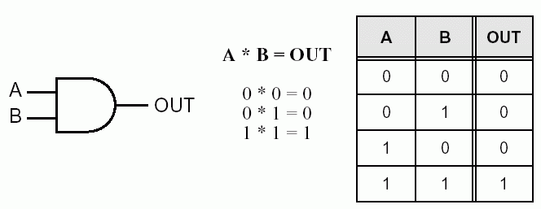  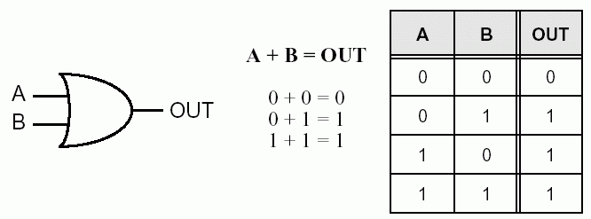  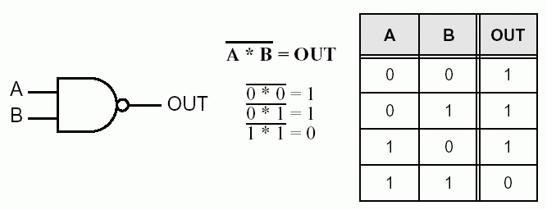  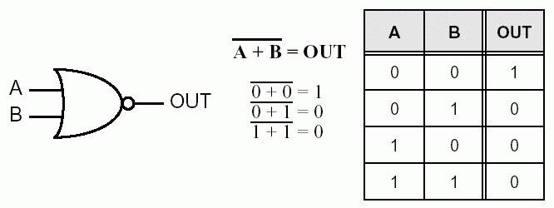

Exercise | - Draw a truth table for 3-input NAND gate and its symbol.  - Write the Boolean algebra for (1) above.  - How to use NOR gate to perform as an inverter? [hint: only one input used for the NOR gate]

Boolean Algebra | 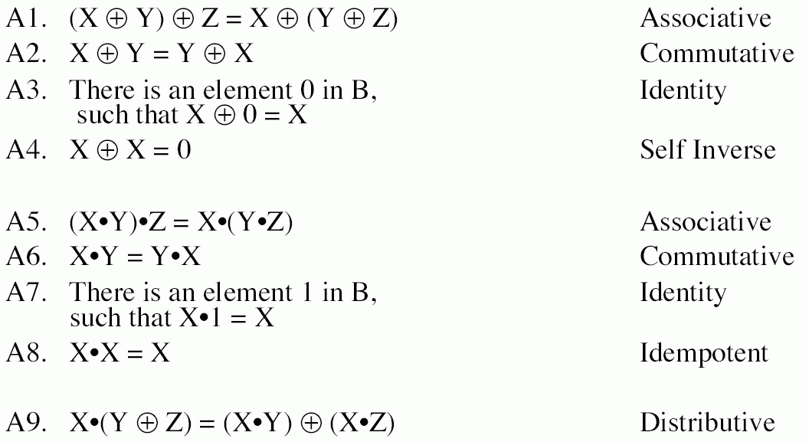

DeMorgon Theorem | - (XY)’ = X’ + Y’  - (X+Y)’ = X’Y’

Exercise | - Prove A + A’B = A + B

