Learning Outcome | At the end of this unit, participants will  - Understand an overview of design flow.  - Exposed to basic layout technique  - Exposed to stick diagram

Introduction | To design an Integrated Circuit, one usually starts with a circuit schematics. Layout is a process to translate the schematic diagram into a set of patterned layers that form the structure in a silicon.

Product Development Flow

PAS Triangle | 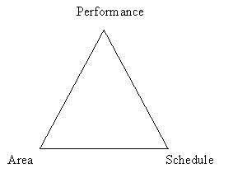
Schematic symbols | - Basic logic gates  - Transistor symbols  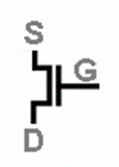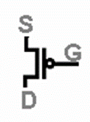  NMOS PMOS  - Power and ground  - Node and Weld Point  - Nodes are defined as physical connections between electrical points  - Weld points identify connections at intersecting nodes.  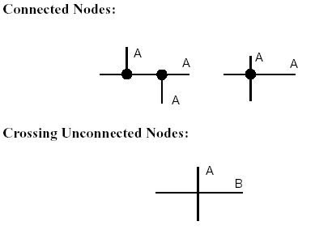

Questions | - How many nodes for the schematic below?  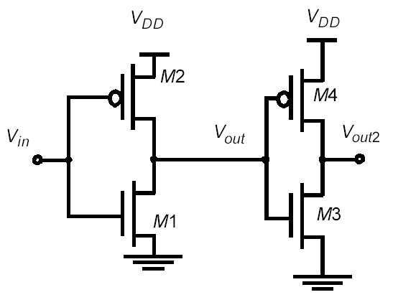  - Answer: Vout, Vin, Vout2, Vdd, Vss

Schematics to Layout conversion | In CMOS design, all logic gates follow 4 governing rules:  - For each input node, there must be 2 transistors, one P-MOS and one N-MOS. The gate nodes of each must be electrically common.  - Example: Inverter – one input, two transistor, one P-mos and one N-mos.  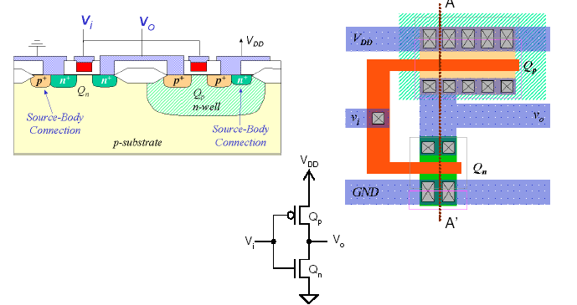  - How about 2-input and 3-input NAND gates? How many transistor?  - The Nmos transistors always match the logical function of the gate.  - The Pmos transistors will always be in a complementary configuration to the Nmos.  - The ordering dot on the logic symbol determine which transistor is placed closest to the output node.  - General Strategy  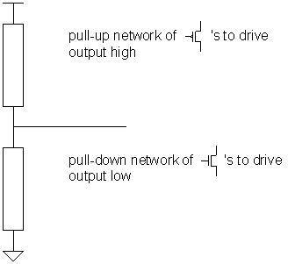  Imagine electrical circuit analogy!  Series – AND gate  a b  ___/ ___/ ___  Parallel – OR gate  a  __/___  ____| |_____  |__/___|  b  - Example: 2 input NAND gate  - 2 input, therefore 4 transistors (2 pMOS and 2 nMOS)  - The nFET transistor match the logic function  F = AB è “and”  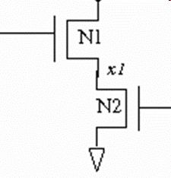  - The pMOS transistor be in a complementary configuration to the nMOS  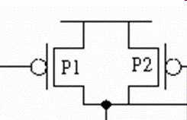  - Ordering dot. Assume the dot is on A. Then A is placed closer to the output node Y.  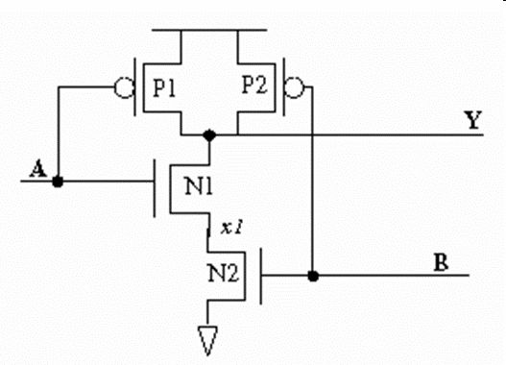  - Draw the transistor level for 2 input NOR gate, dot placed at A  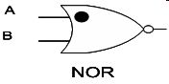

What is Layout  Basic CMOS transistor  Transistor sizing  Routing layers  Example of Schematic and Layout | A process where engineering schematics are transposed into graphic symbols that will be used to make a mask.  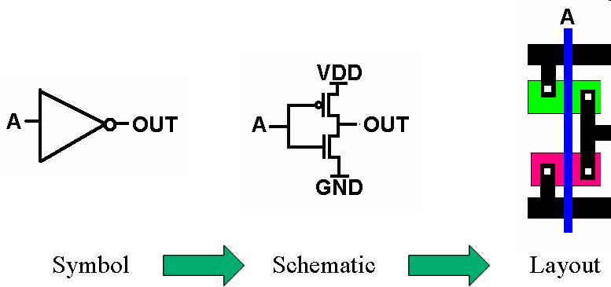  - 2 types, NMOS and PMOS  - Made up logic gates  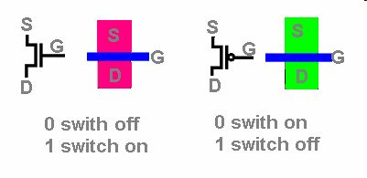  - Transistor sizing notation is Width/Length (Z/L)  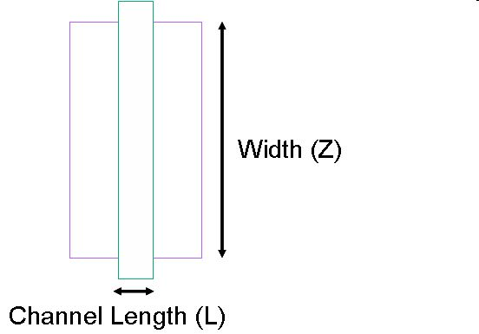  - The sizes for the p and n transistors are usually shown on the schematic with just the widths (z).  - The lengths are implicitly minimum size (see your design rules).  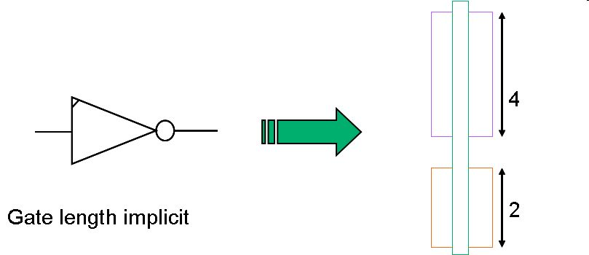  - In this case the gate length is greater than minimum and is specified in the schematic.  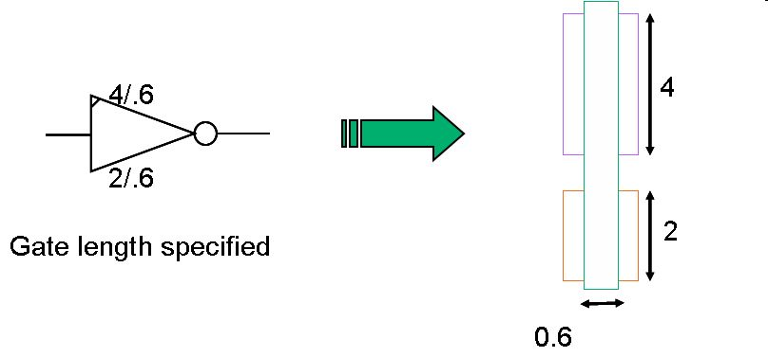  Referring to routable metal layers. Metal 1 and metal 2 as below.  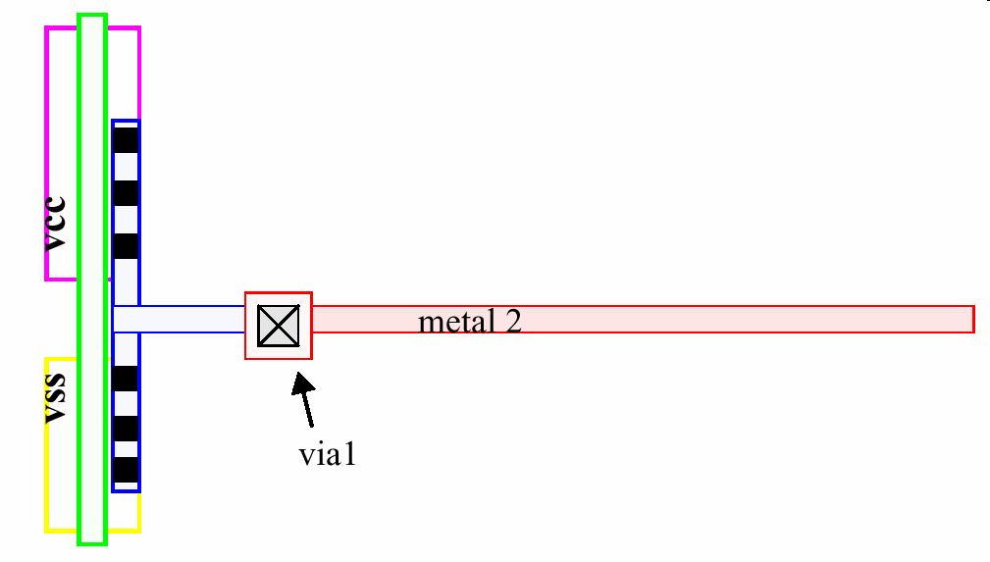  Schematic  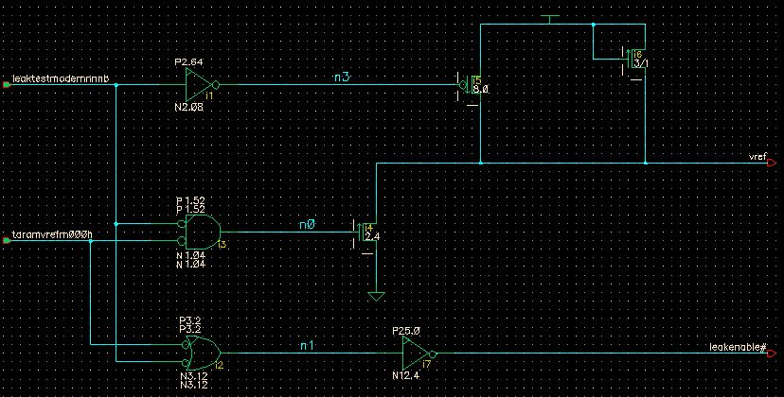  Layout  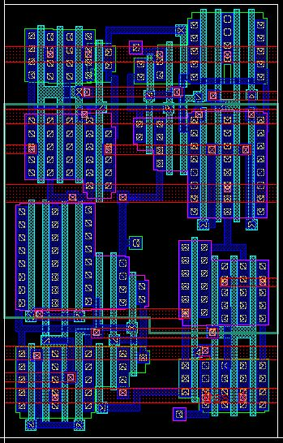
Stick Diagram  Electrical Connection  Stick Diagram Methodology | A short-hand technique for generating a free form, topological plan of a circuit layout, without regard to actual geometry sizing or design rules. Graphical symbols (sticks) are drawn relative to each other and are connected together by symbols (sticks) representing interconnect mask layers.  Stick Diagram Mask drawing  Diffusion – Contact – Metal 1  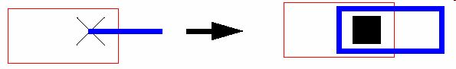  Poly – Contact – Metal 1  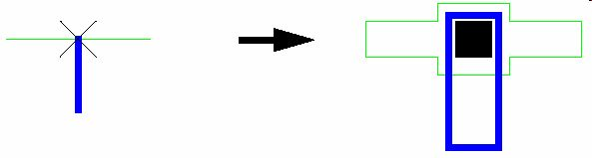  Example: Inverter Stick diagram  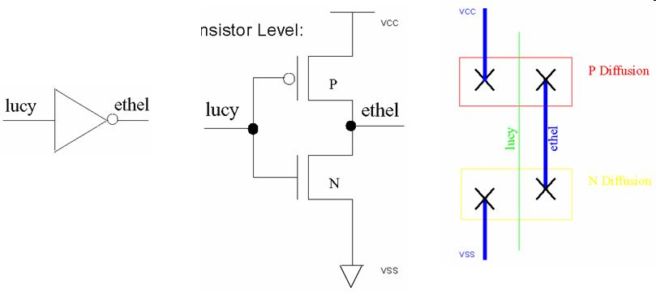  - Group all transistors that share common signal nodes close together (always share internal connections).  - Draw representative diffusions, gates, contacts and metal 1 for each transistor, naming all nodes as you go.  - Systematically connect all the nodes, following the schematic, one node or one transistor at a time.  Exercise 1: Draw the stick diagram for the schematic below and label it accordingly.  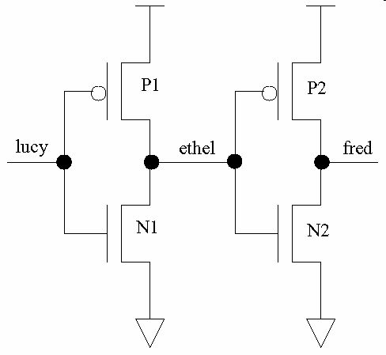  Exercise 2: Convert a 2-input NAND gate from logic symbol to transistor level schematics. Draw the stick diagram as well.  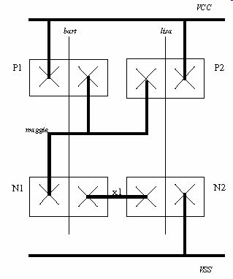  Exercise 3: Draw a stick diagram for 2-input NOR gate.

Diffusion/Node sharing  Advantages of Node Sharing | Definition: The merging of diffusion regions of the same type (Ps or Ns) which are connected to a common electrical node.  Diffusion sharing allows two transistors of the same node and diffusion type to be joined. The two device gates may be brought together as close as design rules allow. We’ll get to design rules soon. For now let’s just say when the shared diffusions require a connection to another circuit element, there needs to be room for a contact plus its needed distances to the gates. When a connection is NOT required, the two device diffusions are brought together to the minimum distance allowed between two device gates.  - Shared Diffusion when further connection to Metal 1 required  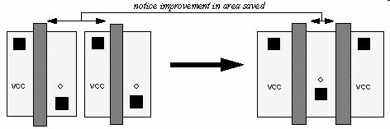  - Shared Diffusion when no other connection required  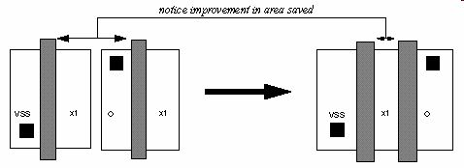  Use the concept of diffusion/node sharing wherever possible. This is always a win-win situation!  - Minimizes cell area  - Diffusion/Node sharing between two devices allows them to be placed closer together. This plays a critical role in minimizing cell area.  - Reduces routing congestion  - Each instance of diffusion/node sharing eliminates the need for a wire to connect the two diffusion terminals. Therefore, it plays a role in reducing routing congestion in a cell.  - Improves parasitics  - As a result of the cell size and routing minimization, there is a parasitic (RC) reduction. This is beneficial from an electrical standpoint.  Example: 2-input NAND gate  1. Unshared  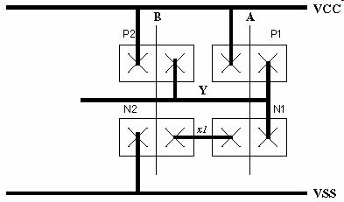  2. Shared  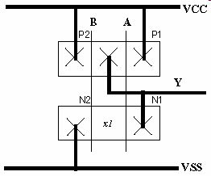
Legging devices | Legging, splitting, or folding a device is the process of breaking a wide device into two or more smaller devices in parallel.  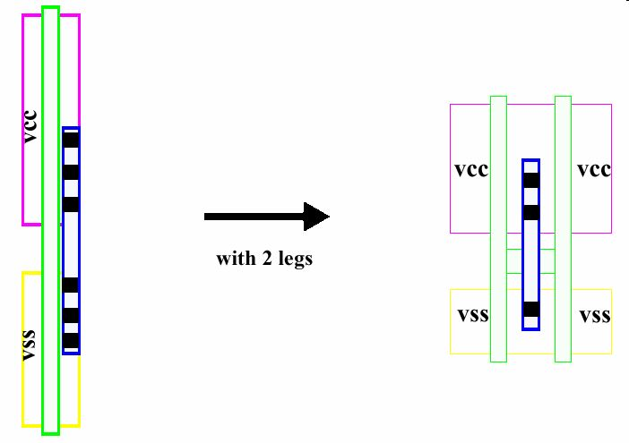  Example: How to leg 2-input NAND gate  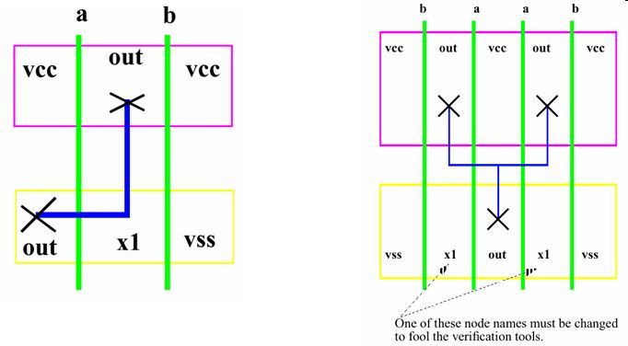

N-Well  Taps | An area of n-type material that is diffused deep into the p-type substrate of the chip. This area then provides a tub/pit/well/hole (however you wish to visualize it) for the PMOS devices to sit in. This tub then electronically isolates the PMOS devices from the substrate and the NMOS devices.  Example: Stick diagram to Hand drawn layout.  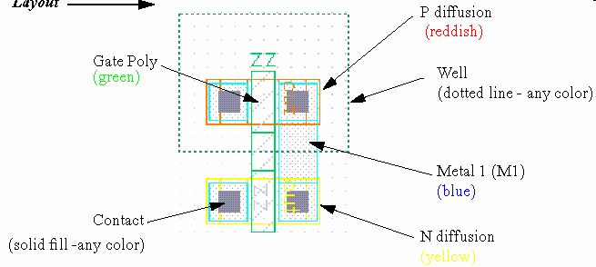  - Well-tap  - A Well Tap is a square of N-type diffusion placed into the N-well and connected through metal to VCC.  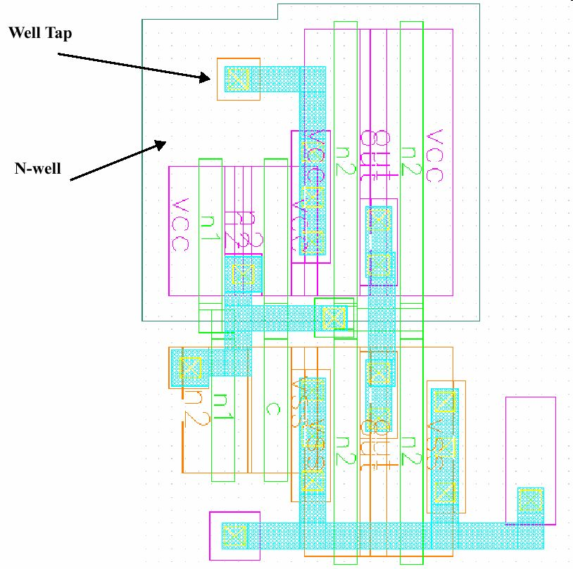  - Substrate Tap  - A Substrate Tap is a square of P-type diffusion placed into the substrate and connected through metal to VSS.  