Learning Outcome | At the end of this unit, participants will  - Know what hierarchy and instance arrays are.  - Be able to traverse hierarchy using schematic and layout tools.  - Be able to create and remove hierarchy in layout.

Introduction | For today design capacity with millions of transistor, it is almost impossible to carry out the implementation with a flat hierarchy design. In order to improve the design cycle throughput time, hierarchy concept is widely used.

Hierarchy  Block diagram of hierarchy  Layout representation of hierarchy  Schematic and layout hierarchy | - Hierarchy - different levels of layout on a chip  - Country → state → county → city → neighborhood  - Chip → cluster → unit → block → cell  - Instance - a cell placed within another cell  - Perak is an instance of a state  - Intel is an instance of a corporation  - Child Cell - cell contained in larger cell is child of that cell  - Parent Cell - cell containing smaller cells is parent of those cells  - Hierarchy organizes & simplifies complexity  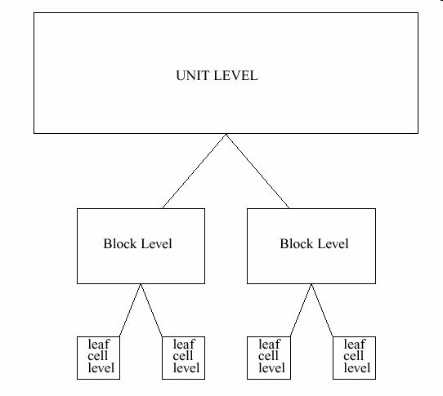  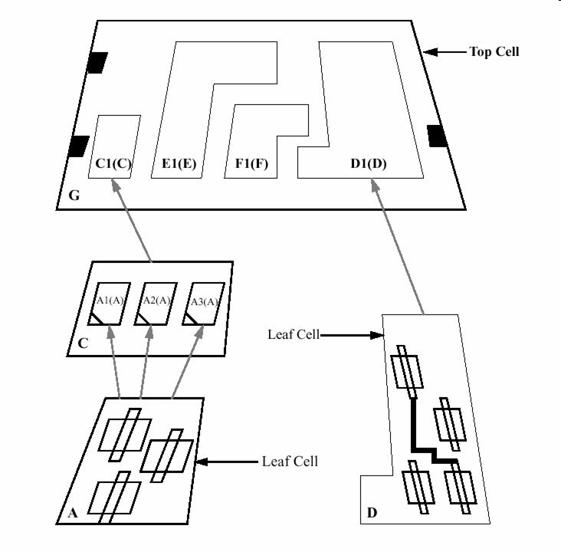  - Hierarchy is usually determined by schematic design  - Hierarchy should make sense for layout  - Suggest modifications if necessary  - Schematic organization of logic follows layout design  - Schematic and Layout hierarchy should match  - Simplifies use of design and verification tools:  - Allows verification to be run at intermediate levels  - Verification runtimes are faster  - Easier to get parasitic data back into simulations  - Easier to complete ECO (Engineering Change Order)

What is array?  Stepped Cells  Stepped Cells with space | - Array - ordered instantiation (placement) of same cell or objects in a design  - Object can be a cell, group of cells, or other structure  - Objects are related, physically and logically  - Array can extend in X and/or Y direction  - Flipping – each alternate instance is the mirror image in X and/or Y direction of the original cell  - Stepping – the distance between neighboring instances  - User can specify stepping (counted from origin to origin of instances)  - Row vs column – row horizontal, column vertical  - The example below shows multiple cell instances placed with the same orientation (no flipping) and same distance between neighbors.  - The origin of the instantiated cell is determined by the small triangle in the lower left corner.  - Origin at X:0, Y:0 of child cell  - Example: 6x1 array of cell circuit  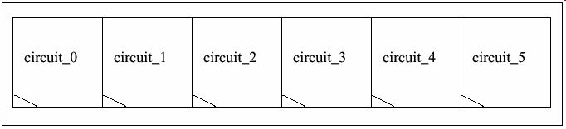  - This example shows multiple cell instances placed with the same orientation, without flipping but with stepping. Notice the equal distance between each cell.  - Example: 4x1 array of cell circuit  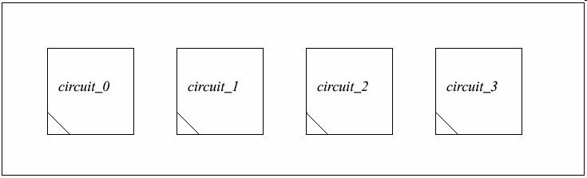
Flipped Cells  Basic hierarchy planning  Understand the constraints  Basic Wire Planning | - This example shows multiple cell instances placed with the same orientation, with flipping and no stepping  - Example: 5x1 array of cell circuit  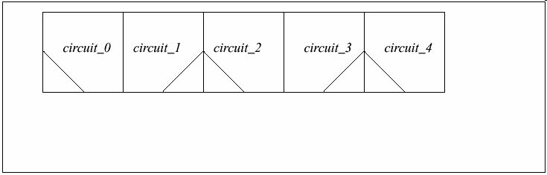  This is included  - Understanding constraints  - Basic Wire Planning  - Block Sizing Fundamentals  - Block Placement Fundamentals  - Datapath Definition  - Basic Datapath Pitch Planning  - Estimating Layout Time  - Interface signals  - Critical signals  - Metal allocations  - Schedule  When creating a wire plan, you need to:  - Include all the input and output pins on your block.  - Include all the M2/M3/M4 feed thru to your block.  - Include shielding if needed.  - Plan to have two or more power lines in larger-pitch cells.  - Use the standard line pitch for signals and power lines (unless they are specified differently).  - Plan to share tracks when possible.

Wire planning example | - Keep in mind, when parallel lines are routed at minimum design rule widths, there is no room to make a connection to the upper layer due to metal overlap requirements for the via.  - Avoid making unnecessary jogs in routing (i.e. if a wire can go straight it should). This will help performance and area.  - Your wire plan specifies the tracks needed for your over-the-cell routing, in conjunction with your port definitions.  - You need a wire plan to see if your fub will be metal-limited and to reserve room for over-the-cell routing. Make sure this is planned before starting layout.  - Estimate the minimum height required to draw this “buffcell” block.
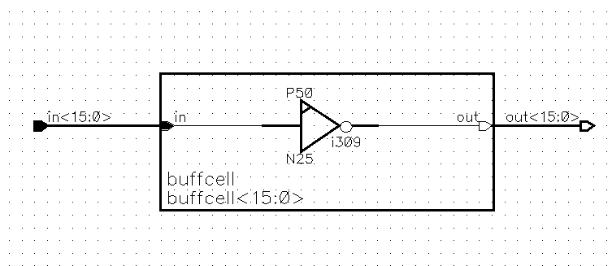
Given: - cell pitch = 12um.
- horizontal M2 lines (minimum space = 0.50um)
. “in” @ metal width = 0.50um
. “out” @ metal width = 0.80 um
. Power lines @ metal width = 1.0um

Then, device legged for 12 times.

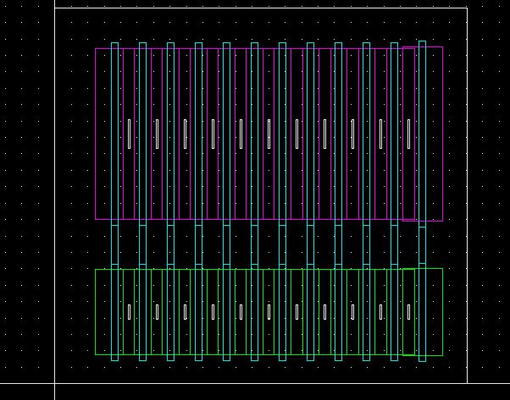

Block sizing fundamentals  Block placement fundamentals | The area required by a design is determined by the number of transistors “device-limited” or by the interconnects “metal-limited”.  - If device-limited, the area is based on transistor density. The density is found by multiplying the number of transistors by the area needed for one transistor (in sq. mils/device).  - If metal-limited, the cell’s area is determined by the total number of line pitch.  - Place blocks efficiently using the least amount of routing. This is especially important for critical nets.  - The Clock driver should be placed close to the clock input.  - If available, use the “Layout Planner” as a template to start placing your blocks.  - Utilize track-sharing and use the cross-reference file to understand how the blocks relate to each other.

Datapath  Basic datapath pitch planning  Estimating layout time | - Datapath describes layout that has the chips’ data buses running through it and being used in it, in a ‘bit-slice’ fashion.  - Data busses are large (up to 86 bits for floating point), and typically use arrays to implement the logic; one cell is created, and then instantiated for each data bit.  - Unique inputs and outputs to particular cell positions (bits) are usually handled with ports.  - Making the right connections at the upper levels is called ‘programming’.  - In planning a datapath pitch (cell width), the pitch will usually be determined by the widest cell.  - It is desirable to match pitches through different parts of the chip to reuse common layout (for example, adders).  - Pitches usually fall in the range between 25 and 60 microns. Outside these values, the aspect ratios become inefficient and/or cumbersome to use.  - Datapath Pitch Planning Process:  - Obtain a cross-reference file for all your blocks.  - Have Wire planning and Cell pitch sizing ready.  - Don’t skimp on power line widths.  - If the pitch seems too narrow for an efficient layout, you can always upsize it. Don’t go any smaller than the worst-case pitch.  - Be creative.  - Plan the layout before estimating the schedule.  - Determine your priorities: is getting the job done quickly or is density* more important for this project?  - 75 devices/week is an example of productivity factor from Wmt project. The actual number depends on the type of layout (Datapath vs. Control vs. Ram) and the layout tools used.  - Do not include your planning time here because Layout and Planning are two different tasks. You should have a plan ready before you can begin to estimate the layout time.

