Learning Outcome | At the end of this unit, participants will  - Design versus Planning Methodology  - Full Chip Roll-up  - Signal Planning  - Assembly  - Large and Complicated Circuits  - Critical Nodes and Special Circuits  - Design Changes

Introduction | - In this section we discuss methodologies for designing and planning at different levels of hierarchy.  - Three methodologies that we will discuss have industry wide names associated with them.  - “Top-Down”  - “Bottom-Up”  - “Middle-Out”

Design vs Planning methodology  Block Planning | Designer need to determine what type of circuitry  - Datapath layout  - Limited in one dimension by pitch and the other by area.  - Random Layout  - Limited in both directions by area  - Array  - Limited in both directions by pitch  Follow these steps while planning a BLOCK:  - How does this block fit into the unit relative to other blocks?  - What direction should metal levels run?  - Is there a pitch that must be followed? Almost all datapath blocks will have a fixed pitch.  - Is there a template cell or pin ring from the top level plan available?  - Is there a pre-determined cell size that is expected to be met?  - What is the layout of the power network?  - Clock network - gate alignment requirements/widths/shielding  - Are there any feedthroughs going through the block?  - Where are the outputs going to and where are the inputs coming from?  - Draw a stick plan of the cell, using all the above information that has been acquired.

Top Down Planning  Area Estimates Per Device Count | In top down planning, there are three main areas of focus:  - Signal cross references  - Area estimates  - Large block preparation  At the full-chip level, planning occurs without any knowledge of what the actual circuitry will look like.  - This is done by using output from design tools that use a High-level Design Language (HDL).  Using the HDL design tools, the chip may be divided into different sections with different circuit functions associated with each section.  - We will call the sections clusters.  - Some examples of clusters might be a BUS cluster, an ALU cluster, or a MEMORY cluster.  There may be many different types of layout that will effect the device area. For our purposes, we will use three categories of layout types:  - Array  - Datapath  - Random Logic  Each type of layout has a different device density factor.  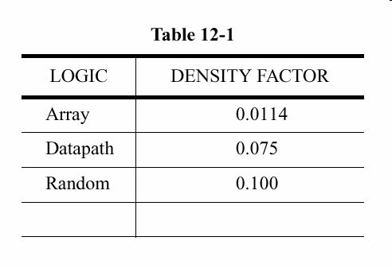
Bottom Up Planning  Array Cell Layout  Full Chip (FC) Roll Up | - In bottom-up planning the area of focus is on leaf cells or cell studies (layouts done early in the project).  - This planning is used after the cluster level planning is finished.  - Repeated structures such as datapath, memory arrays and decoders are sized to help with the final sizing of each block.  - Array Cell layout includes RAM and ROM arrays, decoders, drivers and any other highly repeated structures.  - Use the same planning process as you would for datapath planning except arrays are usually done in PLE. Because these structures are repeated so many times, it is valuable to get them as small as possible. Using PLE allows you to use the smaller array design rules which in turn gives you a smaller cell.  - In this situation taking longer to draw something smaller is better than getting it done faster because of the amount of area you could save.  - Example: Layout of Array Leaf Cell  - The array leaf cell will set the pitch in the x and y direction for the entire array and interfacing cells  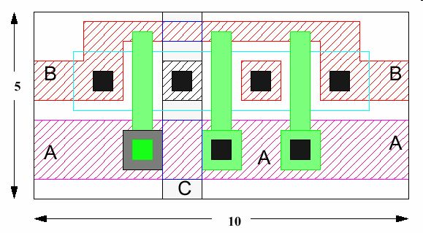  A Full Chip Roll-up is a coordinated checkin of all data into a central library. This provides the fullchip planners a “snapshot” of the design to work with. This event occurs approximately once every 3-4 months and more often toward the end of the project, but varies depending on the project.
Signal Planning  Pin Placement | This section discusses the basic concepts involved in planning inter-block signal flow. Proper signal planning is essential in minimizing area. It is also important from an engineering perspective, as certain critical signals will require special considerations for speedpath reasons.  - Pin Placement from cross-reference files (review)  - Parasitic information  - Metal Layers  - Metal Widths/spacings  - Shielding  - Channel Routing  - Signal cross-reference files are generated from High-Level Design Language (HDL) tools. These files are then used to determine block placement in such a way as to minimize interconnect (which will minimize routing area).  - Once the optimal block placement is determined, the pins can be assigned to a block edge.  - Unless bottom-up layout considerations dictate otherwise, pins should be placed on block edges to minimize signal routing distances.  - An example is shown below, which shows a group of signals common to two blocks separated by a small channel.  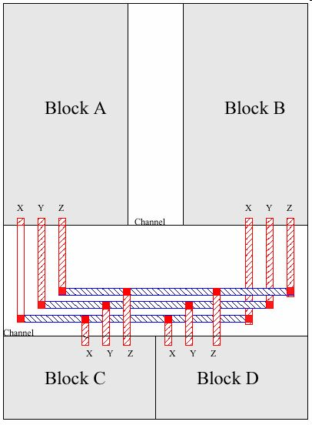

Parasitic Consideration | - Parasitic is usually referring to Resistance and Capacitance (RC).  - Parasitic information is an important aspect of signal planning. Speed-critical signals identified by engineering may need to be routed in particular metal layers and with specific widths. Noise-sensitive signals may need to be spaced at certain distances from other switching signals, or be shielded from other signals by power (VCC/VSS). All of these issues should be discussed with the engineer prior to, during, and after you do any planning.
Metal layer RC | - Resistance and capacitance (RC) values for each individual layer need to be taken into account when planning signal routing, as certain layers have higher values than others.  - Upper metal layers, such as Metal5 and Metal6 would be used mainly for global power and clock signals, and therefore not available for local signals without the approval of the unit planner.  - For the remainder of this discussion, assume that these conditions are true.

Metal Spacing and Width  Signal necking | - Increasing the width of each layer reduces the resistance over a given length, thus increasing the speed. The speed critical signals will usually need to be routed not only in a particular layer or layers, but also in particular widths determined by engineering. The width will vary according to the speed increase required by the signal and the particular RC values for each layer.  - Design engineer need to avoid signal necking. For critical signal, it might act like a fuse. The broken connection may kill the entire chip.  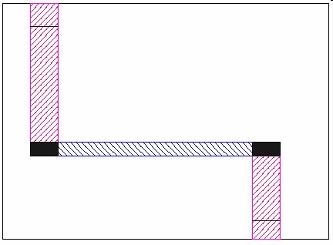
Shielding  Assembly | - Shielding is accomplished by surrounding the signal with power (therefore non-switching) signals (VCC/VSS), either on the same layer as the signal (lateral shielding) or adjacent layers (vertical shielding).  - Noise-sensitive signals may also be protected from electrical coupling by shielding.  - Example: Signal is fully shielded.  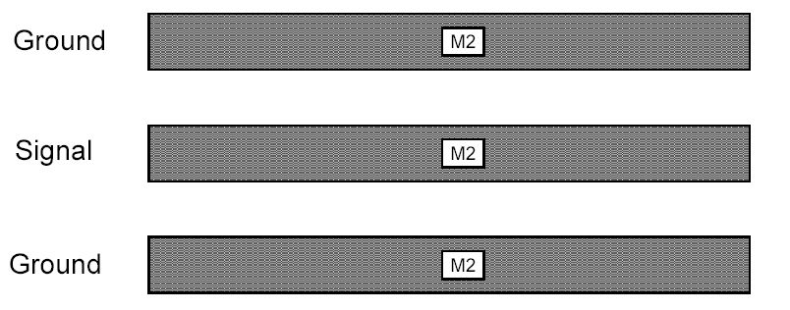  - Half-shielded  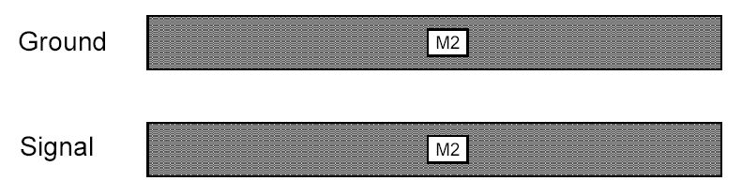  - Assembly is an ongoing task. It is performed not just once, when all sub-block layout is complete, but at frequent intervals.  - Any block area changes, or block pin changes which affect channel area, can be identified as early as possible.  - This is important, as any growth in area is more easily accommodated early in the design process. It also allows for the fullchip and other unit interfaces to be accommodated.  - Top-down pin placements need to match bottom-up layout. It is extremely important to read in actual bottom-up pin rings from DLS top level database whenever they become available.  - This enables pins abutting the blocks to be adjusted to match (and channels to be re-routed using the new pin locations)  - It also enables the assembler to feed back any problems encountered such as . . .  - wrong metal layers/widths  - missing/extra pins  - pin on the wrong edge of the block  - block area changes

Design Change | - Any changes should be done in Enginering Change Order (ECO).  - ECOs are changes filed by either you OR the engineer to let everyone know that your unit or block is changing. These changes could be because of device size changes, wire width, spacing or routing needs that have to be fixed.  - Some Sources of Design Changes  - Layout Reviews  - ECOs  - Reliability Verification  - ECO items that are documented.  - Priority, Status  - Title, Owner  - Areas Affected  - Model & Stepping  - ETA  - ECO Reason, Cause, Description, Justification  - Approval & AR lists

Exercise | - Draw the stick diagram for the cells. The cells will further be assembled to form a new cells.

