Learning Outcome | At the end of this unit, participants will  - Understand custom layout and auto place and route layout.  - Understand basic flow for Auto Place and Route.

Introduction | Auto Place & Route tool is widely used today to improve the time to market for an IC. Today vendor tool can take care of various design issue like signal integrity, design rules violation, power consumption and static timing analysis.

Full custom layout comparison | - Datapath Layout  - Repeated complex structures like sense amplifiers, decoders, adders, multipliers -- in general, a datapath with tight control over area, signal noise, bit symmetry.  - Analog Layout  - High performance or analog circuitry layout.  - This includes phase-locked loops (PLLs), digital-to-analog converters or analog-to- digital converters (DACs/ADCs), electrostatic discharge (ESD) structures, regulators, radio frequency (RF) speed requirements, or techniques to meet low-power needs layout.  - Custom digital Layout  - Full-custom layout that requires greater attention to area and performance than the full digital (ASIC) flow.  - Less stringent requirements for speed  - Less need for control over device-level layout than datapath or analog layout  - It is also known as “random logic layout."  - Standard library cells layout  - Cells are defined as logical building blocks that are part of a family of components that share common abutment rules, performance characteristics, or functionality.  - Examples would include the cells within a standard cell library or family of Pad cells.

Analog Layout | - Analog layout is the place were the layout designer needs to understand the phenomena that happens within the devices, physical connections, implants, and needs to have a good knowledge of semiconductor physics. 1+1 ≠2  - Requirement: Interlaced devices, common centroid placement and connectivity, differential pairs routing, substrate noise and jitter – importance for cell/block performance.  - The schematic, in this case, contains a lot more information than the previous flow. Circuit designers have to make a lot of assumptions when running a simulation. In the case of analog design, where the margins of error and tolerances are very small, the schematic needs to contain a lot of information to assist the layout implementation designer meet those assumptions. Each simulator is using models for devices based on the width and length of the device, number of fingers per device, the multiplication factor, and so forth. So it is important for the layout to follow 100 percent of the design needs. However, verification tools can't check for all of these "finesse" requirements -- they have to be implemented by methodology.  - Example: Phase-locked loops (PLLs), digital-to-analog converters or analog-to- digital converters (DACs/ADCs), electrostatic discharge (ESD) structures, regulators, radio frequency (RF) circuitry.

Device Matching | - This is a common requirement for Analog design.  - Example:  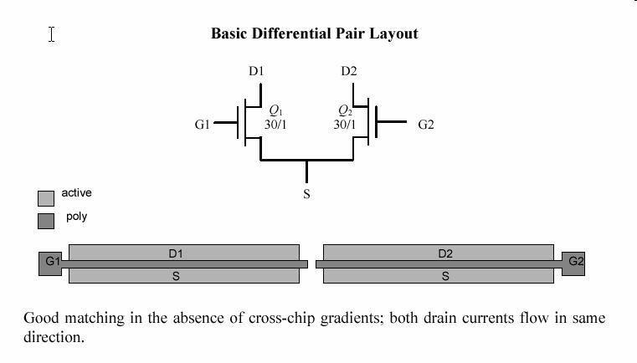  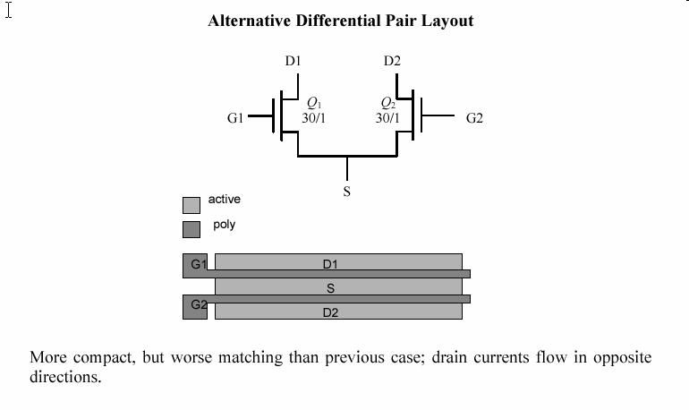  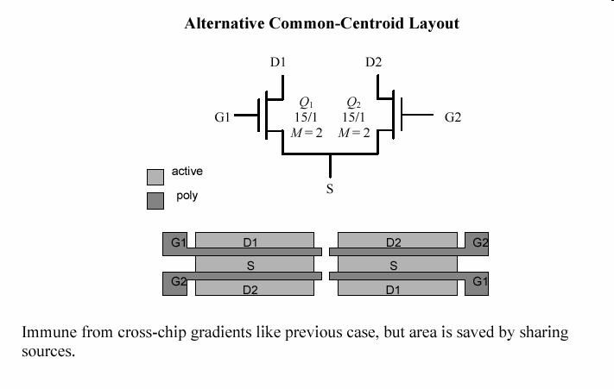  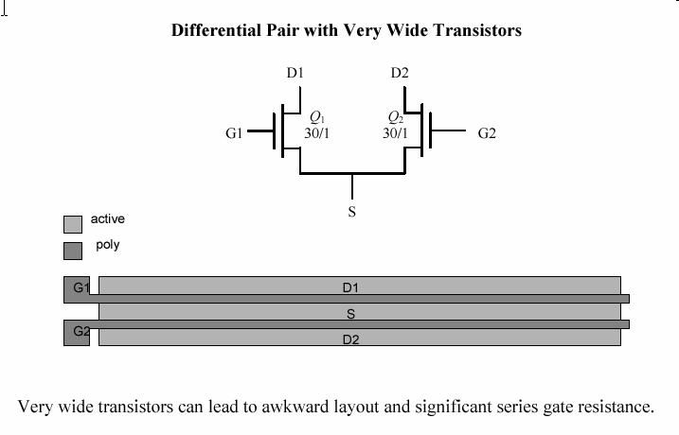  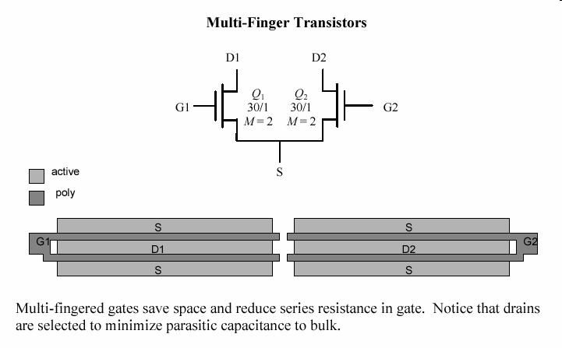  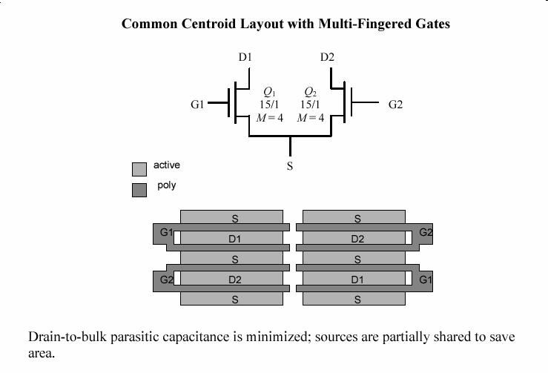  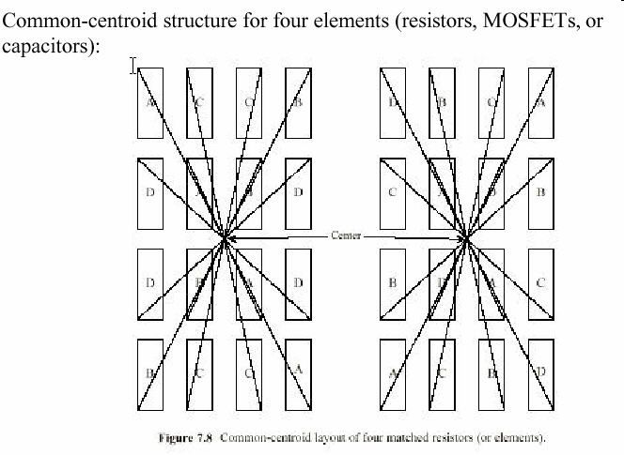

Gold Rules of Matching | - If you follow some simple rules, you can avoid gross matching problems. When a designer is trying to ratio two transistors:  - Use the same W and L and vary M (takes out .W and .L effects)  - Use common-centroid, or nearly common-centroid, layout (takes out oxide and doping gradients)  - Use dummy transistors at the ends of the row (takes out poly etch loading and mask misalignment effects)  - Make clean and well balanced routing  - Use a suitable area and overdrive  - Use plenty of substrate and well taps  - Route currents a long way, not voltages - IR drops can cause big mismatches

Auto Place and Route | - Advantages of APR tool  - Ability to handle digital designs of 10+ million gates flat  - Extremely fast turnaround time in achieving design closure  - Integrated power planning, analysis, and routing for full-chip power structure  - Easy-to-use clock tree synthesis handles multiple and reconvergent clocks  Source: http://www.cadence.com/products/digital_ic/nano_encounter/index.aspx  - Used standard cells approach. Also known as cell-based-design (CBD). All the digital cells (including NOT, NAND, NOR, XOR, latches, flip-flops, buffer and complex gates) are having same height and already pre-layout before the design.  - How APR fit into the design  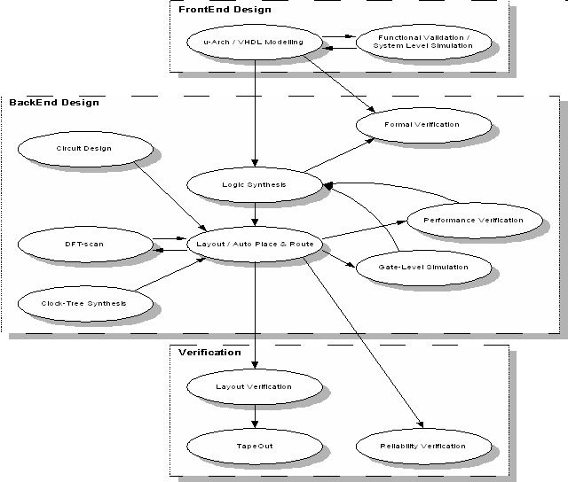

Typical Logic Design Flow  Example of APR outcome | 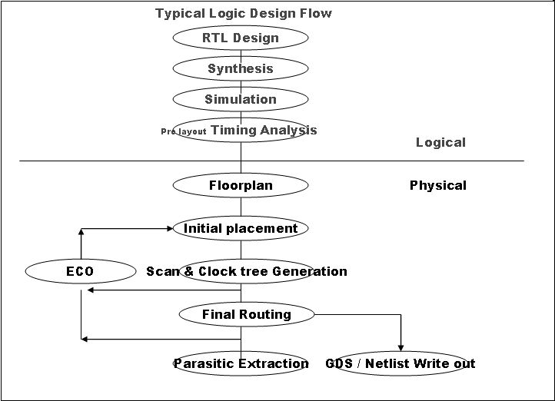  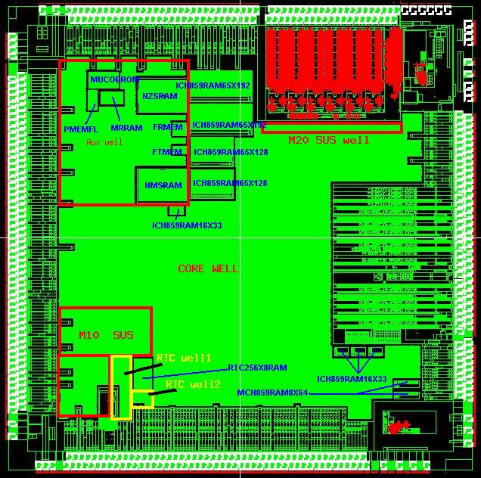
Standard Routing Flow | 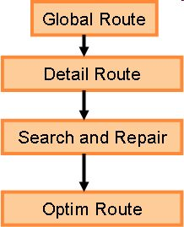  - Global Route  - Provide a overall routing capability.  - Usually it is faster than detail routing phase because it doesn’t resolve any DR violation.  - Cost setting applied here where user can instruct the router to use certain layer specifically to route certain signal. Designer tend to use high metal to route timing critical signal, where RC is smaller for higher metals.  - It performs track assign.  - Detail Route  - Run time is longer.  - Performed DR correction. DR might reduced 50% or more but will not clean DR for the design.  - Search and Repair  - Performed DR correction to the tool limitation.  - Optim Route  - To correct the routing and reduce the metal jog after DR correction in Search and Repair.  - Depending on the designer input, it may used to add via to the connection, i.e. from single via to double via.

Reference | - www.eedesign.com/story/OEG20010608S0035  - www.conformity.com  - http://www.cadence.com/products/digital_ic/nano_encounter/index.aspx

