Learning Outcome | At the end of this unit, participants will  - Proliferate Basics Layout ESD strategy  - Understand layout for ESD Do’s and Don’ts  - Exposed to good ESD layout connection.  - Understand phenomenon of latch up.

Introduction | ESD is like a miniature lightning bolt. When lightning strikes, it is because charge concentrations in the clouds create strong electric fields with respect to earth. When the potential is high enough, lightning occurs.  A similar situation exists with ESD, albeit on a much smaller scale. When a person becomes triboelectrically charged (i.e., through friction), a difference in potential exists between that person and nearby conductive objects. When that potential exceeds the breakdown voltage of the intervening air, an electrostatic discharge results.

ESD Basic | - ESD – Electro-Static Discharge  - ESD is defined as the current flow between 2 objects with different electrostatic potential. Normally ESD is concerned with rapid current flows.  - ESD events: Damage can occur to an IC when  - Charges accumulated on the human body or manufacturing equipment are imparted to a chip through one of its pins. If, for example, the charge on the human body is discharged as a current of 10µA flowing for 1µs to a gate capacitor of Cg = 0.025pF, then the voltage which will build up on the transistor gate is  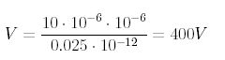  - The chip itself collects charges and then one of its pins is grounded.  - Such a voltage destroys MOS transistors, therefore, ESD protection is essential for the I/O circuitry.  - A typical solution of the ESD protection problem is to use clamping diodes implemented using MOS transistors with gates tied up to either GND for nMOS transistors, or to VDD for MOS transistors as shown in figure below.  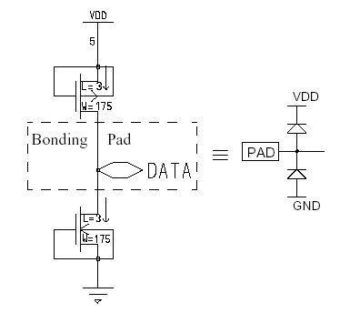  - For normal range of input voltages these transistors are in the off state. If the input voltage builds up above (or below) a certain level, one of the transistor starts to conduct clamping the input voltage at the save level.  - These clamping transistors are very big structures (in the example of figure above L = 2ג,W = 175ג) consisting of a number of transistors connected in parallel, and are able to sustain significant current.

ESD Layout Failure | 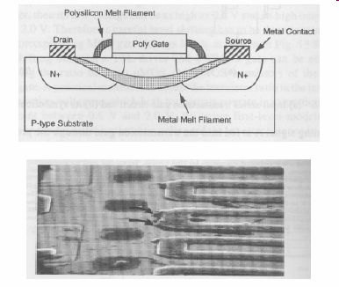

Additional ESD Layout Design Rules | 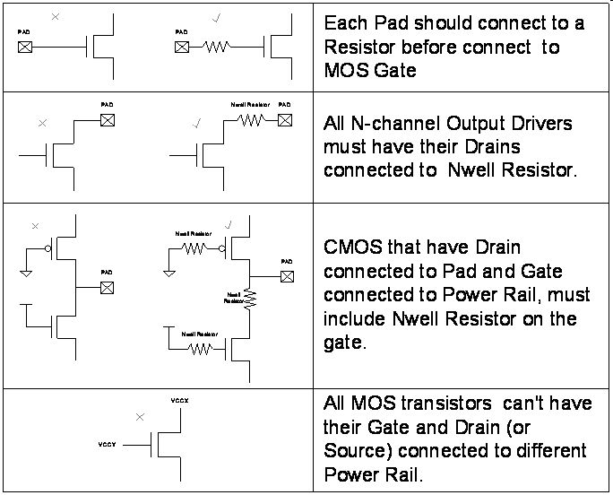

Layout for ESD | - Planning  - Choose power rails to go over Pdriver or D2 for top-down connect  - Choose pwr/gnd rails for top-down connect to D6/D7 & clamps  - Don’t put D1/D2 diodes lengthwise down buffer  - Decide on “ESD style” and know required amt of diode width  - Metal Width  - If ESD rules can’t be met, then balance diode entry & exit metal widths, after discussion with QRE  - Metal width rules only matter getting to the cell, not within the cell  - Don’t need to add up individual segments of diode to meet rules  - Don’t need to add up metal fingers of clamp to meet rules  - Diode Integrity  - Use min Pdiff/Ndiff DR spacing  - Use min contact/contact DR spacing  - Contact opposite contact ensures good current flow  - Ensure M1 over diffusion is continuous & max via density

Latch Up in CMOS | - Large MOS transistor are susceptible to the latch-up effect. In the chip substrate, at the junctions of the p and n material, parasitic pnp and npn bipolar transistors are formed as in the following cross-sectional view:  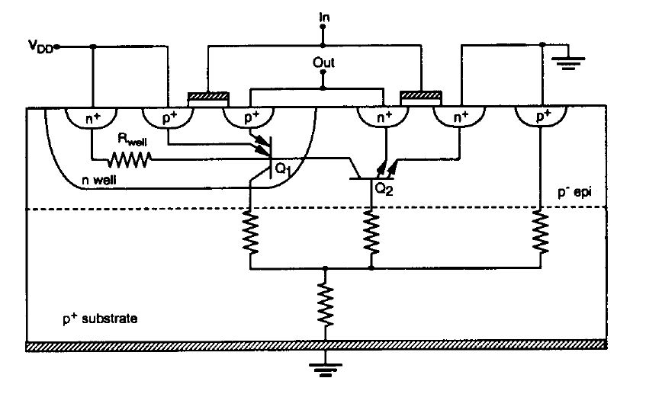  - These bipolar transistors form a silicon-controlled rectifier (SRC) with positive feedback as in the following circuit model:  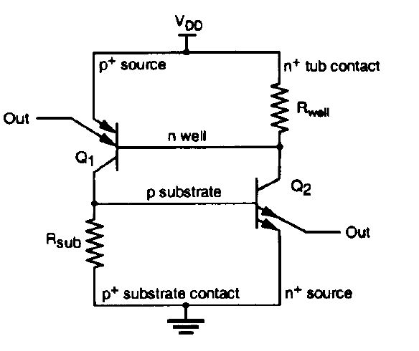  - The final result of the latch-up is the formation of a short-circuit (a low impedance path) between VDD and GND which results in destruction of the MOS transistor.

Guidelines for avoiding Latch up  (Quoted from Kang, Leblebici) | - Use p+ guard rings connected to ground around nMOS transistors and n+ guard rings connected to VDD around pMOS transistors to reduce Rw and Rsub and to capture injected minority carriers before they reach the base of the parasitic BJTs.  - Place substrate and well contacts as close as possible to the source connections of MOS transistors to reduce the values of Rw and Rsub.  - Use minimum area p-wells (in case of twin-tub technology or n-type substrate) so that the p-well photocurrent can be minimized during transient pulses.  - Source diffusion regions of pMOS transistors should be placed so that they lie along equipotential lines when currents flow between VDD and p-wells. In some n-well I/O circuits, wells are eliminated by using only nMOS transistors.  - Avoid the forward biasing of source/drain junctions so as not to inject high currents; the use of a lightly doped epitaxial layer on top of a heavily doped substrate has the effect of shunting lateral currents from the vertical transistor through the low- resistance substrate.  - Lay out n- and p-channel transistors such that all nMOS transistors are placed close to GND and pMOS transistors are placed close to VDD rails. Also maintain sufficient spacings between pMOS and nMOS transistors.

Reference | - A.P.Papli´nski lecture notes  - www.csse.monash.edu.au/~app/CSE3142/Lnts/

