Learning Outcome | At the end of this unit, participants will  - Able to layout basic logic gates such as inverter, NAND, NOR gate.  - Understand basic verification flows for layout.  - Exposed to layout CAD tool.

Introduction | Today layout designer is heavily depending on CAD tool to implement layout from the schematics. CAD tool can be used to generate the device layout automatically. However, it is important for a mask designer to layout the device manually.

Layout Verification  What is Design Rules (DR)  Design Rules Example  Design Rules violation  Fixing Layout Error  LV in the design cycle | - Drawn correctly and matches schematic data  - Layout Verification (LV) is the process of checking layout for design rule violations and making sure it matches the schematics.  - Design Rule Verification  - Checks the graphic layout for conformance to the rules prescribed for a given process and reports violations. The individual rules or checks are referred to as design rule checks (DRC) and the violations are referred to as design rule violations (DRV).  - Connectivity Verification  - Detects opens and shorts in the layout. It also verifies that the graphic layout accurately represents the schematic by extracting connectivity information (a netlist) from the layout and comparing it with the schematic netlist. Mismatches between the netlists are reported as errors. The flow to check for this correctness and any resulting errors is referred to as comp (CMP).  - Geometric constraints imposed on the layout to avoid unwanted results in the fabrication of a die.  - Design rules are specific for each process technology.  - Project Specific  - Design Rule Document  - Design rules define the minimum and maximum allowable drawn dimensions.  - The most common types of design rules that you work with are “width”, “space” and “enclosure”. Of course there are many more design rules check.  - Layout is like putting together a jigsaw puzzle. Only you do not always put the same pieces together in the same place to make the same picture over and over.  - Be creative, as long as you follow the design rules and stay within the allotted area.  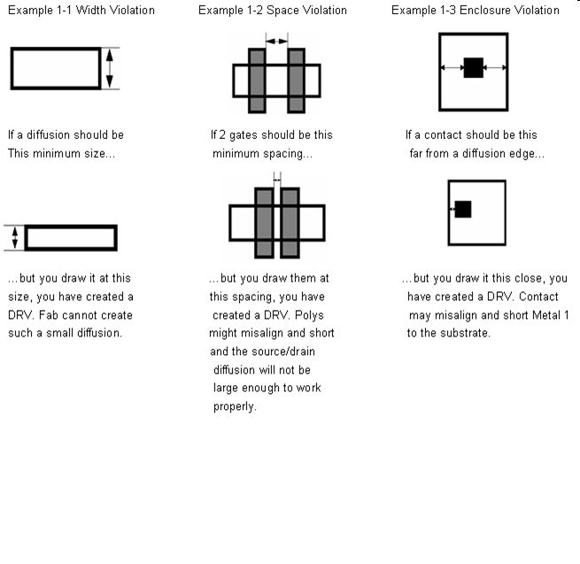  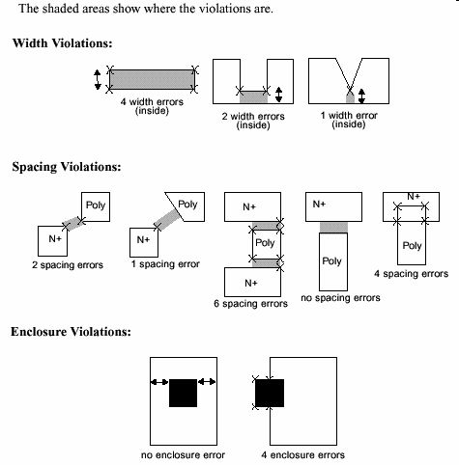  - Typical Layout Errors found in .cmp file:  - Missing Devices  - Extra Devices  - Wrong Type  - Shorts  - Opens  - Wrong Hookup  - Device Size (Z/L)  - Severe Errors (Opens)  - LV – Layout Verification  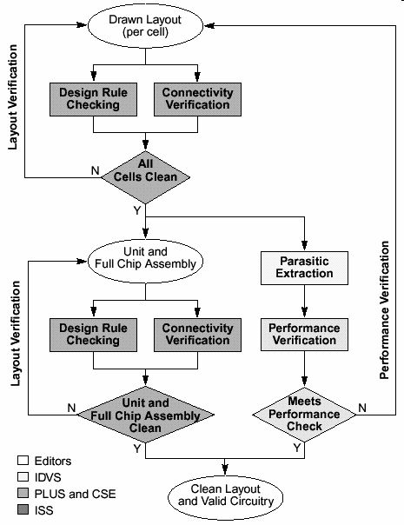

Lab 1  Exercise 1  Exercise 2  Exercise 3 | Download freeware Microwind and manual from  http://intrage.insa-tlse.fr/~etienne/Microwind/#mwEdit  Other CAD tool can be used to perform the lab.  Draw a layout for inverter as below.  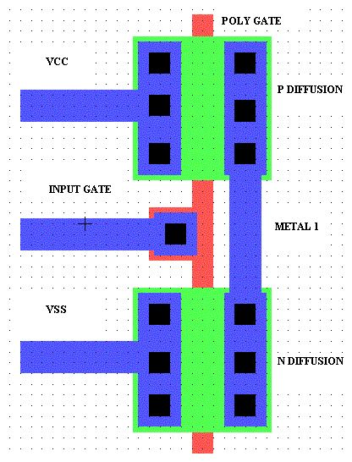  Draw a NAND gate with below specification.  - Pmos - 18ג  - Nmos - 10ג  Draw a NOR gate with below specification. Split gate to 2 leg.  - Pmos – 20ג  - Nmos – 14ג

